Behaviour Procedures
Aims
These procedures for the management of behaviour in school are written in accordance with the St John Bosco Catholic Academy Behaviour Policy: Link.
St. John Bosco Catholic Multi Academy recognises that the common good requires social conditions that allow all people to achieve their full human potential and realise their human dignity. Central to this is the need for strong relationships rooted in the love and example of Jesus Christ. Our schools must provide a broad and balanced Catholic education which will help children and young people grow to their full God-given potential. The curriculum, ethos and culture must pay full regard to the formation of the whole person so that:
‘all may attain their eternal destiny and at the same time promote the common good of society. Children and young persons are therefore to be cared for in such a way that their physical, moral and intellectual talents may develop in a harmonious manner, so that they may attain a greater sense of responsibility and a right use of freedom, and be formed to take an active part in social life’
Code of Canon Law, Canon 795.
Members of the local governing body and staff aim to create a positive and nurturing learning environment in each school by:
- Following a whole school approach to positive behaviour and discipline with clear guidelines and consistency in the use of rewards and sanctions, underpinned by the Catholic values ethos of the school.
- Building self-esteem, self-discipline and positive relationships based on mutual respect and the example of Jesus Christ.
- Ensuring everyone is treated equally and fairly, promoting the equal opportunities policy regarding the 9 protected characteristics in the Equality Act (2010)
- Supporting staff in their classroom management by ensuring and assuring a consistent and fair approach to positive and negative behaviour.
- Using behaviour tracking, recording and monitoring systems to enable timely intervention and support where needed.
- Using a variety of innovative and creative intervention strategies to overcome barriers to learning.
- Working with a diverse range of outside agencies and professionals to ensure the needs of all children and young people are met.
- Providing a safe, nurturing environment free from disruption, violence, bullying, intimidation and any form of harassment.
- Encouraging, promoting and facilitating a positive, trusting relationship with parents and carers to develop a shared approach to their child’s education which involves them in the implementation of all aspects of this and other relevant policies
Safeguarding
The school recognises that changes in behaviour may be an indicator that a pupil is in need of help or protection.
We will consider whether a pupil’s misbehaviour may be linked to them suffering, or being likely to suffer, significant harm.
Where this may be the case, we will follow our child protection and safeguarding policy, and consider whether pastoral support, an early help intervention or a referral to children’s social care is appropriate.
Please refer to our child protection and safeguarding policy for more information: Link.

School behaviour curriculum
The SJBCA Behaviour policy sets out the expected behaviours for each of its schools. At St. Mary’s, we create a culture that promotes excellent behaviour by:
At St. Mary’s we develop children’s character through our behaviour curriculum. In order to build character, we define the behaviours and habits that we expect students to demonstrate. We want to support our pupils to grow into adults who are polite, respectful, grateful and who always consider others. We believe that as pupils practise these behaviours, over time they become automatic routines that positively shape how they feel about themselves and how other people perceive them.
Teaching the curriculum
The curriculum is taught explicitly during the first week in Autumn term alongside the traditional National Curriculum subjects. Children should learn the content of the curriculum so that they can recall the information and act upon it. At the start of each term, the behaviour curriculum is revisited with pupils and will continue to be reinforced throughout the year. As with other curriculum content, this should be taught using explicit teaching based on the ten principles of instruction from Barak Rosenshine including regular quizzing to check and strengthen retention. Teachers will also demonstrate these behaviours and ensure pupils have time to practise these (particularly in the first few days of term). For example, a lining up order should be taught in the classroom but must be reinforced in different locations and times throughout the school day e.g. at lunchtime. It is expected that all pupils will know this content.
See more by reading our Behavioir Curriculum document:
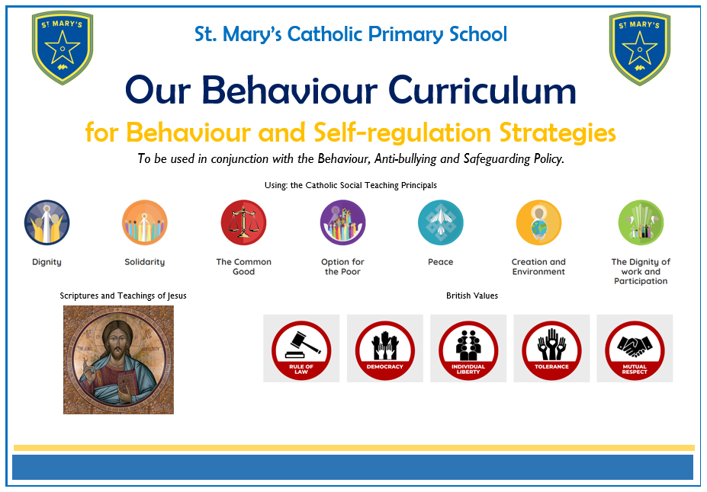

Where appropriate and reasonable, adjustments may be made to routines within the curriculum to ensure all pupils can meet behavioural expectations in the curriculum.

Responding to behaviour
Classroom management
Teaching and support staff are responsible for setting the tone and context for positive behaviour within the school.
They will :
Create and maintain a stimulating environment that encourages pupils to be engaged. They will:
- Display the our school rules, curriculum and own classroom rules – designed and taught by the children.
- Develop a positive relationship with pupils, by:
  - Greeting pupils in the morning/at the start of lessons
  - Establishing clear routines
  - Communicating expectations of behaviour in ways other than verbally
  - Highlighting and promoting good behaviour
  - Concluding the day positively and starting the next day afresh
  - Having a plan for dealing with low-level disruption
  - Using positive reinforcement
  - Use of the Silent Signal to gain the attention of the class.
  - Wonderful Walking to keep everyone safe in the school.
  - Lovely Listening so we can all learn without distraction.
  - Clever Contributing so that we can all join in with our learning and play.
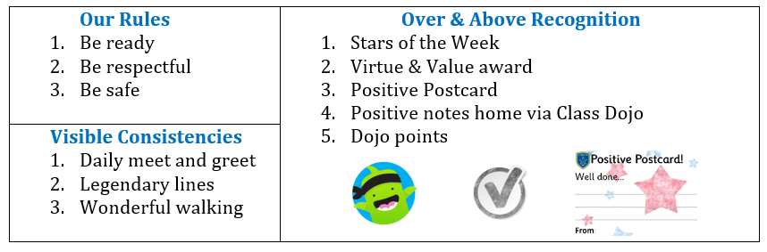

Responding to good behaviour
When a pupil’s behaviour meets or goes above and beyond the expected behaviour standard, staff will recognise it with positive recognition and reward. This provides an opportunity for all staff to reinforce the school’s culture and ethos.
Positive reinforcements and rewards will be applied clearly and fairly to reinforce the routines, expectations and norms of the school’s behaviour culture.
Positive behaviour will be rewarded with:
- Verbal praise
- Communicating praise to parents via a Dojo Posts, Message or pictures
- Certificates, prize ceremonies or special assemblies – Positive Postcards, Star of the Week Certificates and Virtual and Value Awards
- Positions of responsibility, such as pupil leadership status or being entrusted with a particular decision or project
- Whole-class or year group and house group awards.
Responding to misbehaviour
When a pupil’s behaviour falls below the standard that can reasonably be expected of them, staff will respond in order to restore a calm and safe learning environment, and to prevent recurrence of misbehaviour.
Staff will endeavour to create a predictable environment by always challenging behaviour that falls short of the standards, and by responding in a consistent, fair and proportionate manner, so pupils know with certainty that misbehaviour will always be addressed.
De-escalation techniques can be used to help prevent further behaviour issues arising, such as the use of pre-arranged scripts and phrases.
All pupils will be treated equitably under the policy, with any factors that contributed to the behavioural incident identified and taken into account.
When giving behaviour sanctions, staff will also consider what support could be offered to a pupil to help them to meet behaviour standards in the future.
The school may use 1 or more of the following sanctions in response to unacceptable behaviour:

- REMINDER:
I noticed you chose to … (noticed behaviour)
This is a REMINDER that we need to Be (Ready, Respectful, Safe).
You now have the chance to make a better choice.
Thank you for listening.
Example: ‘I notice that you’re running. You are breaking our school rule of being safe. Please walk. Thank you for listening.’

- WARNING:
I noticed you chose to … (noticed behaviour)
This is the second time I have spoken to you.
You need to speak to me for two minutes after the lesson.
If you choose to break the rules again you leave me no choice but to ask you go to the quiet area /thinking mat (learner's name).
Do you remember when … (model of previous good behaviour)? That is the behaviour I expect from you.
Think carefully. I know that you can make good choices.
Thank you for listening/I’m glad we had this conversation.
Example: ‘I have noticed you are not ready to do your work. You are breaking the school rule of being ready. You have now chosen to catch up with your work at playtime. Do you remember that yesterday you started your work straight away and got it finished? That is what I need to see today. Thank you for listening.’

- CALMING TIME:
I noticed you chose to … (noticed behaviour)
You need to:
(INDOORS) Have some thinking time (teacher to decide an appropriate space IN CLASS)
(OUTDOORS) Have some thinking time (walking around with an adult)
I will (come to) speak to you in two minutes.
Example: ‘I have noticed you chose to use rude words. You are breaking the school rule of being respectful. You have now chosen to go and sit in the quiet area. I will come and speak to you in two minutes. Thank you for listening.’
*TIME IN not TIME OUT that counts.
*DO NOT describe child’s behaviour to another adult in front of the child.
*At this point, parents informed verbally, either in person at the end of the school day or over the phone. Messages should not be relayed through other relatives/childminders or left as a voicemail message, other than to ask the parents to contact school at the earliest opportunity.

- FOLLOW UP, REPAIR AND RESTORE
What happened? (Neutral, dispassionate language)
What were you feeling at the time?
What have you felt since?
How did this make people feel?
Who has been affected? What should we do to put things right? How can we do things differently?
*This is to be done verbally, not in written form.
“Remember it’s not the severity of the sanction, it’s the certainty that this follow up will take place that is important.” Paul Dix

Sanctions should:
- make it clear that unacceptable behaviour affects others and is a serious offence against the school community;
- not apply to a whole group for the activities of individuals;
- be consistently applied by all staff to help to ensure that pupils and staff feel supported and secure;
- need to be in proportion to the offence.
It should also be made very clear that it is the behaviour that is unacceptable, and any sanction should address this, not be made personal to the pupil.

Adult strategies to develop excellent behaviour
- IDENTIFY the behaviour we expect
- Explicitly TEACH behaviour
- MODEL the behaviour we are expecting
- PRACTISE behaviour
- NOTICE excellent behaviour
- CREATE conditions for excellent behaviour

Language around Behaviour
At St. Mary’s, we understand that a common and consistent use of language around behaviour is essential in creating clear boundaries to learn how to behave. Phrases such as ‘kicked off’ or ‘screaming fit’ are unhelpful in these instances and we should remain professional and calm at all times.
Conversations should follow a script and behaviours should be discussed as the behaviours they are, and not be personal to the child.
Conversations around behaviour should be conducted, in the first instance, by the class teacher.

Personal circumstances of the pupil will be taken into account when choosing sanctions and decisions will be made on a case-by-case basis, but with regard to the impact on perceived fairness.
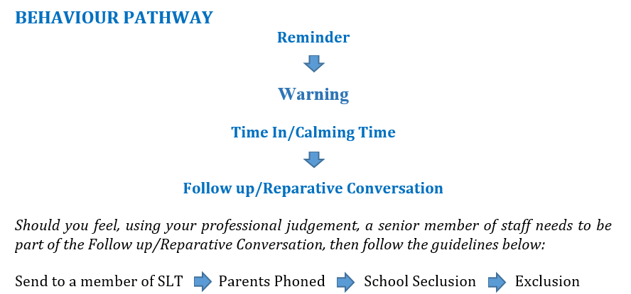

Serious sanctions
Suspension and permanent exclusions
The school can use suspension and permanent exclusion in response to serious incidents or in response to persistent poor behaviour, which has not improved following in-school sanctions and interventions.
The decision to suspend or exclude will be made by the principal and only as a last resort.

Responding to misbehaviour from pupils with SEND
Recognising the impact of SEND on behaviour
The school recognises that pupils’ behaviour may be impacted by a special educational need or disability (SEND).
When incidents of misbehaviour arise, we will consider them in relation to a pupil’s SEND, although we recognise that not every incident of misbehaviour will be connected to their SEND. Decisions on whether a pupil’s SEND had an impact on an incident of misbehaviour will be made on a case-by-case basis.
When dealing with misbehaviour from pupils with SEND, especially where their SEND affects their behaviour, the school will balance their legal duties when making decisions about enforcing the behaviour policy. The legal duties include:
- Taking reasonable steps to avoid causing any substantial disadvantage to a disabled pupil caused by the school’s policies or practices (Equality Act 2010)
- Using our best endeavours to meet the needs of pupils with SEND (Children and Families Act 2014)
- If a pupil has an education, health and care (EHC) plan, the provisions set out in that plan must be secured and the school must co-operate with the local authority and other bodies.

As part of meeting these duties, the school will anticipate, as far as possible, all likely triggers of misbehaviour, and put in place support to prevent these from occurring.
Any preventative measures will take into account the specific circumstances and requirements of the pupil concerned.
Where SEND behaviours have occurred at a greater frequency, staff will use the STAR recording system to help identify triggers.
Adapting sanctions for pupils with SEND
When considering a behavioural sanction for a pupil with SEND, the school will take into account:
- Whether the pupil was unable to understand the rule or instruction?
- Whether the pupil was unable to act differently at the time as a result of their SEND?
- Whether the pupil is likely to behave aggressively due to their particular SEND?
If the answer to any of these questions is yes, it may be unlawful for the school to sanction the pupil for the behaviour.
The school will then assess if it is appropriate to use a sanction and if so, whether any reasonable adjustments need to be made to the sanction.
Considering whether a pupil displaying challenging behaviour may have unidentified SEND
The school’s special educational needs co-ordinator (SENCO) may evaluate a pupil who exhibits challenging behaviour to determine whether they have any underlying needs that are not currently being met.
Where necessary, support and advice will also be sought from specialist teachers, an educational psychologist, medical practitioners and/or others, to identify or support specific needs.
When acute needs are identified in a pupil, we will liaise with external agencies and plan support programmes for that child. We will work with parents to create the plan and review it on a regular basis.
Pupils with an education, health and care (EHC) plan
The provisions set out in the EHC plan must be secured and the school will co-operate with the local authority and other bodies.
If the school has a concern about the behaviour of a pupil with an EHC plan, it will make contact with the local authority to discuss the issue. If appropriate, the school may request an emergency review of the EHC plan. Through contacting the caseworkers of the Sandwell Inclusion Support service.

Supporting pupils following a sanction
Following a sanction, the school will consider strategies to help pupils to understand how to improve their behaviour and meet the expectations of the school.

Pupil transition
Inducting incoming pupils
The school will support incoming pupils to meet behaviour standards by offering an induction process to familiarise them with the behaviour policy and the wider school culture. Midyear intake pupils will be offered a sample day, then be received through the front of the school, met by the class teacher and partnered up with a positive role model within the class to help induct.
Preparing outgoing pupils for transition
To ensure a smooth transition to the next year, pupils have transition sessions with their new teacher(s). In addition, staff members hold transition meetings.
To ensure behaviour is continually monitored and the right support is in place, information related to pupil behaviour issues may be transferred to relevant staff at the start of the term or year.

Training
As part of their induction process, our staff are provided with regular training on managing behaviour, including training on:
- Use of Dojo for positive behaviour.
- Understanding of the Behaviour Policy and Curriculum.
- Guidance with logging behaviours on Abor.
Behaviour management will also form part of continuing professional development.

Monitoring arrangements
Monitoring and evaluating school behaviour
The school will collect data on the following:
- Behavioural incidents, including removal from the classroom
- Attendance, permanent exclusion and suspension
- Use of pupil support units, off-site directions and managed moves
- Incidents of searching, screening and confiscation
- Anonymous surveys for staff, pupils, governors, trustees and other stakeholders on their perceptions and experiences of the school behaviour culture
The data will be analysed every term by SLT.
The data will be analysed from a variety of perspectives including:
- At school level
- By age group
- At the level of individual members of staff
- By time of day/week/term
- By protected characteristic
The school will use the results of this analysis to make sure it is meeting its duties under the Equality Act 2010. If any trends or disparities between groups of pupils are identified by this analysis, the school will review its policies to tackle it.
Monitoring this policy
This behaviour policy will be reviewed by the principal and Local Governing Board at least annually, or more frequently, if needed, to address findings from the regular monitoring of the behaviour data (as per section 13.1).

Links with other policies
This behaviour policy is linked to the following policies:
- SJBCA Behaviour Policy
- Exclusions policy
- Child protection and safeguarding policy
- Physical restraint policy
- Mobile phone policy
- Anti-Bullying Policy
- Online Safety Policy

